2nd TRANSNATIONAL PARTNERS MEETING
November 22-23, 2022
Minutes
Project: Foreign workers in social sector
No.: 2021-1-CZ01-KA220-VET-000025630
Meeting room: CRA UZS, Na Pankráci 322/26, Prague 4, Czech Republic

Participants:
- CRA UZS: Vít Jásek, Jaromíra Kotíková
- APSS CR: Tereza Havelková
- Social Employers: Alina Pavicevac, Tamara Gomez-Sanchez
- AKMI: Konstantina Tsakalou
- Elisfa: Joëlle Garello, Theo Bezerra
- Service Mensch: Barbara Gscheitmayr, Barbara Gurtner

- Presentation of country reports
In the first part of the Transnational partners meeting (hereinafter referred to as "TPM"), all partners of the project presented their country reports, in which were presented:
- the legislative analysis of the employment of foreign workers,
- the results of a questionnaire survey and structured interviews between employers and employees - foreign workers,
- the results of the focus group.

The presentations of individual partners are listed in the appendix.

For most partners, it was possible to get in the required number of questionnaires from employers and conduct structured interviews with them. Unfortunately, it was not possible to get in the required number of questionnaires from foreign workers. The required number of questionnaires and interviews was achieved only in the Czech Republic and Austria. Only 1 interview took place in Greece and none in Belgium. This low number of interviews is related to the low number of completed questionnaires (only 12 in Belgium). The organization Social Employers from Belgium tried by all available means to get at least some answers to the questionnaires from foreign workers, but it did not succeed.

Partners who have achieved low numbers of questionnaires or conducted interviews must prepare a justification and also write down all the ways in which they tried to achieve the desired results. The project coordinator will then inform the Czech NA about the lack of results and we will wait for its decision on how to proceed.

Focus groups on the results of questionnaire surveys and interviews have already been held in the Czech Republic, Austria, Greece and France. In Belgium, the Focus group will be held in December. The Belgian partners were asked to open the topic of the insufficient number of questionnaires from foreign workers also in the Focus group with employers and to try to find the reasons why foreign workers are not interested in answering and participating in structured interviews.

The total results achieved as of November 2022 are shown in the table.

AKMI, Social Employers, Elisfa: prepare a justification and write down all the ways in which they tried to achieve the desired results
Service Mensch: prepare a justification for why only 4 people participated in the Focus group
Deadline: end of November, 2022
Results as of November 23, 2022 | Required number in each country | Total number per 5 countries | CZ | GR | BE | FR | AT | Actual number
Questionnaires – employers | 50 | 250 | 72 | 40 | 67 | 49 | 63 | 291 (+41)
Questionnaires – employees | 50 | 250 | 79 | 35 | 12 | 20 | 50 | 196(-54)
Interviews – employers | 10 | 50 | 10 | 6 | 9 | 10 | 12 | 47 (-3)
Interviews – employees | 10 | 50 | 10 | 1 | 0 | 6 | 10 | 27 (-23)
Focus group (date, number of participants) | 10 | 50 | Oct, 10 | Nov, 10 | Dec | Nov, 9 | Nov, 4 | 33 (-17)

2. Summary of country reports
All project partners were asked to complete their country reports and send them to the project coordinator by the end of November. Social employers will send a complete country report after the Focus group. The country reports will also contain:
- a justification why it was not possible to achieve the required number of questionnaires or structured interviews
- key findings for each country regarding the employment of foreign workers.
Based on all country reports, a Summary report will be compiled. This Summary report will be prepared by CRA UZS. This report must be completed by the end of January 2023, so all partners have been asked to submit their country reports on time. A summary report will be sent to all partners for comments. On the basis of this report, Social Employers can start compiling Guidelines and recommendations as part of the PR2 project activity.
All partners: complete the country report and send to the project coordinator
Deadline: the end of November, 2022

CRA UZS: prepare a Summary report and send it to partners for comments
Deadline: January, 2023

3. Project outputs from PR1
In the appendix to these minutes, we are sending a list of all project outputs for PR1 - Analysis in partner countries. The table shows the individual outputs and the form in which the partners should have them developed.
Comments on individual outputs:
- It is not necessary that evaluations of questionnaires, structured interviews and analysis of legislation be developed separately. All these sections can be included in the Country report.
- Online questionnaires - all partners will send the project coordinator a link to both questionnaires and will have at their disposal an Excel table with the results of the questionnaires
- Records from structured interviews - partners will keep records from all conducted interviews for possible check. The minutes of each interview is enough. The template is saved on Google drive. The records remain stored with the relevant partner, they will not be sent to the Project Coordinator.
- Informed consent - each participant in the interview should sign an informed consent that they agree to the interview and state their name and contact. If the person does not agree to the signature, it is enough to state their name and note that the person did not agree to the signature instead of the signature. Informed consents remain stored with the relevant partner, they will not be sent to the Project Coordinator.
- Focus group - it is necessary to send the Project Coordinator an agenda, a scan of attendance sheets with signatures, a report (template on Google drive), presentations, etc.

All partners: All partners will send all required documents during December. The country report will be sent by the end of November at the latest.
Deadline: December 22, 2022

4. Next steps in the project
In January 2023, Social Employers will start working on creating Guidelines and recommendations. The basis will be the Summary report and key findings for individual countries. These Guidelines and recommendations should be ready by May 2023, and then a Focus group on these recommendations should be held in each country. In June, the 3rd TPM will take place in Belgium, where the results will be presented. Final Guidelines and recommendations should be drawn up by the end of July 2022.
An online meeting of partners will take place in January 2023 and Guidelines and recommendations will be discussed in more detail.
Based on these proposals, the AKMI educational program will be created. Work on the creation of this educational program should begin in August 2023, an online version of the education should be created by the end of 2023, and testing of the education in each country for 8-10 people will take place in January-March 2024.
The involvement of external teachers in the pilot testing of the training program was discussed. Unfortunately, it is not possible to finance external persons from the project. This would be a subcontract under exceptional costs that is not included in the budget. The pilot verification of the educational program is to take place in 01-03/2024, and for this educational part it is possible to involve teachers/trainers and allocate part of the budgeted number of days for the PR3 activity with the same daily rate as the researcher. The only condition is that the teacher/trainer has an employment contract with the relevant project partner.
Certification of the educational program is not required in this project. Participants will only receive a confirmation of participation in the training. However, CRA UZS would like to have this education included among the educational courses organized by APSS CR in the Czech Republic in the future.

5. Questions
1. Is it possible to use part of the funds in exceptional costs for translations and design for another activity? E.g. to involve experts in education or other activities?
2. Is it possible to use part of the grant for Multiplier event participants to rent a room for a Focus group?

APSS ČR: will verify with the Czech NA
Deadline: until the end of December 2022

6. Project management book
The Project management book, which is stored on Google Drive, was presented to the partners. The presentation of this document is given in the attachment. Project management book clarifies project and financial management and set the effective internal and external communication and provides guidance to reporting procedures, partners´ obligations and responsibilities.
During the meeting, the partners filled in the persons who will be members of the Steering committee, the persons responsible for individual project activities and the partners' websites. Key milestones of the project were also added, on the occasion of which a press release will be issued. All these data will be listed in the Project management book.
The partners were also presented with individual Report periods and deadlines for sending reports (see table below). All supporting documents required by the Czech NA for individual project activities are also listed in the Project management book.
 | Report period | Deadline for sending report
1. | 02/2022 – 07/2022 | August 31, 2022
2. | 08/2022 – 01/2023 | February 28, 2023
3. | 02/2022 – 04/2023 | May 10, 2023 – for interim report
4. | 02/2023 – 07/2023 | August 31, 2023
5. | 04/2023 – 12/2023 | December 22, 2023 – for sub report
6. | 08/2023 – 01/2024 | February 29, 2024
7. | 02/2024 – 07/2024 | August 31, 2024 – for final report

All partners: read the document and write any comments or comments on APSS CR
Deadline: until the end of December 2022

AKMI: add a delegate to the Steering committee to the main representative
Deadline: end of November, 2022

APSS ČR: send a template for an internal report to partners
Deadline: end of December, 2022

7. Dissemination plan
The project dissemination plan, which is stored on Google Drive, was presented to the partners. The presentation of this document is given in the attachment. The partners agreed that each partner would prepare a report on the project website on a free topic during the project.

APSS CR: prepare a news on the project website on a free topic
Deadline: until mid-December, 2022

All partners: send AKMI social media accounts (linked In, FB)
Deadline: until mid-December, 2022
All partners: collect information about dissemination activities (articles about the project, information on the web, social networks, etc.) for the preparation of an internal report.
Deadline: end of January, 2023

Service Mensch and AKMI: check if AKMI has a translation of the website into German available, if not, Service Mensch will complete it
Deadline: until mid-December, 2022

Photos:
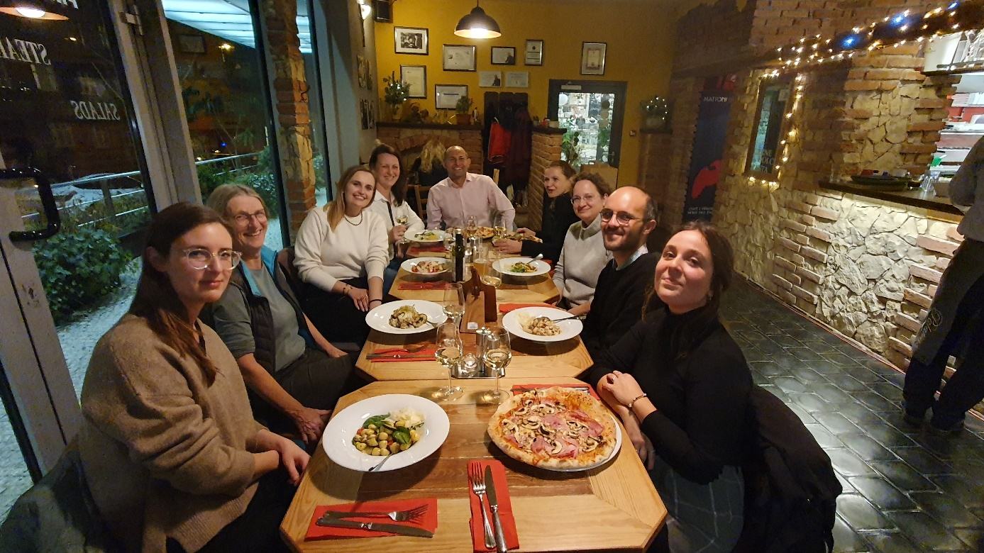

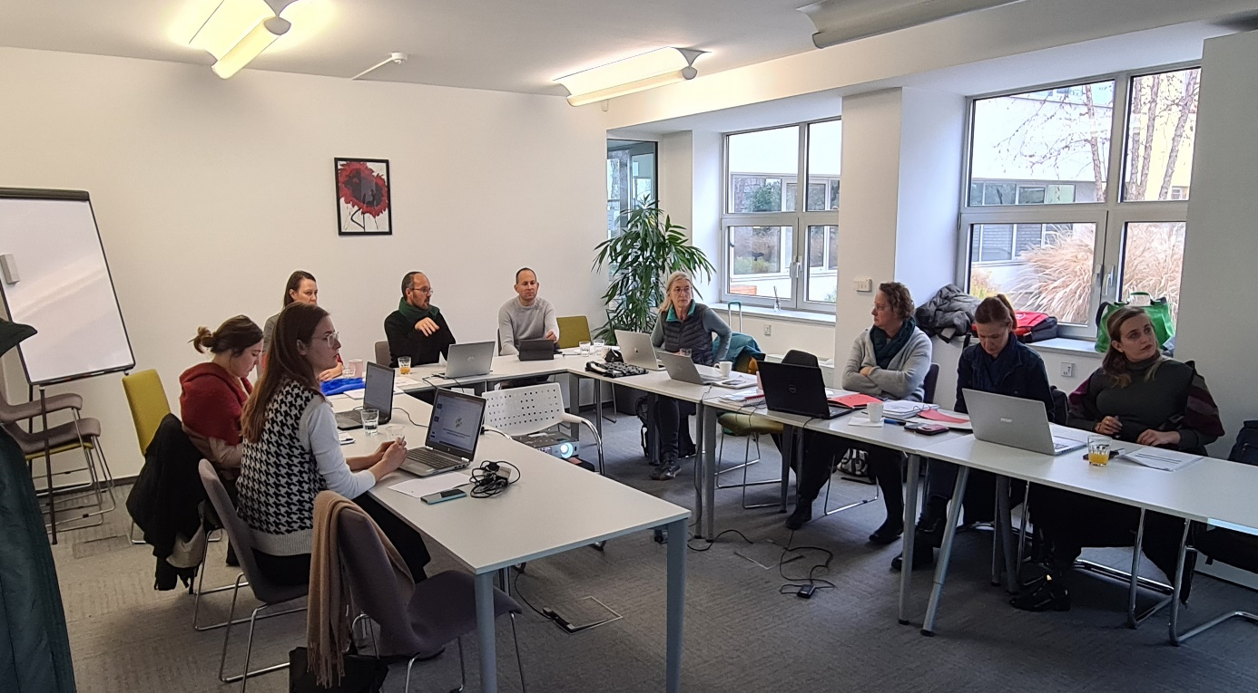

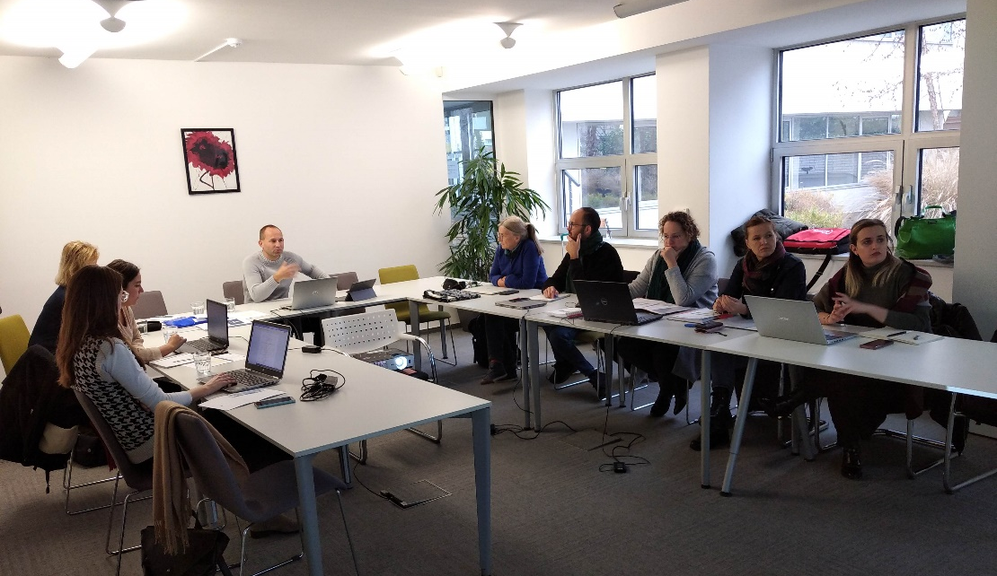
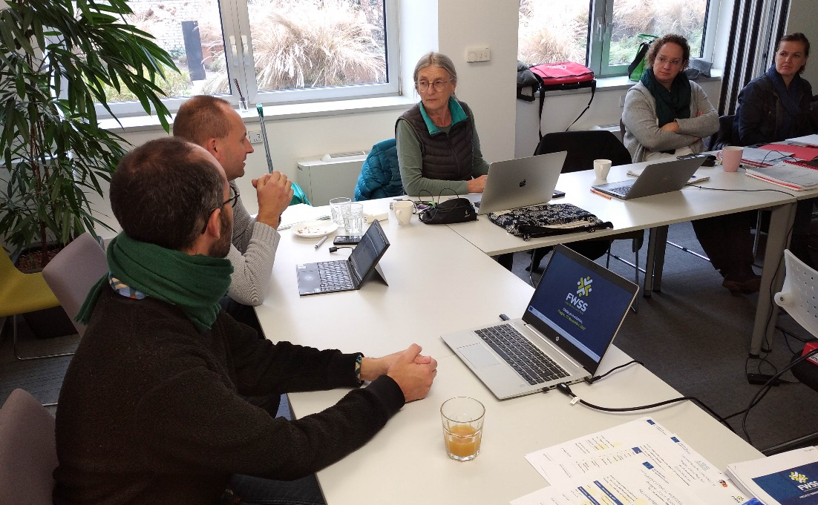
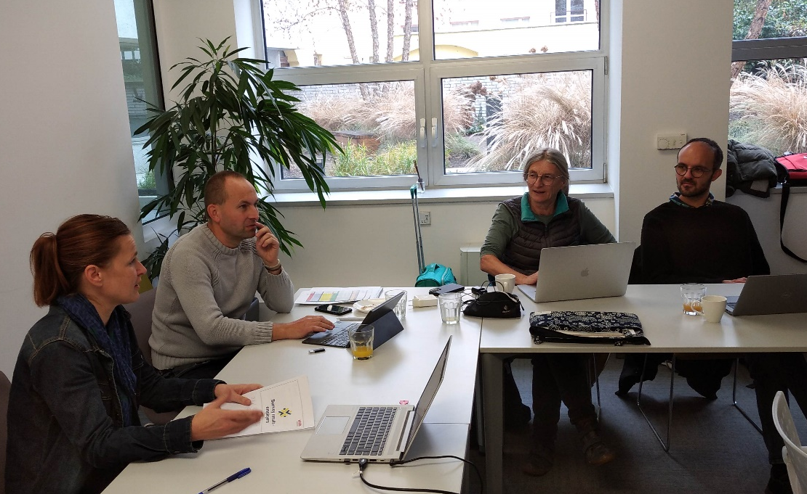
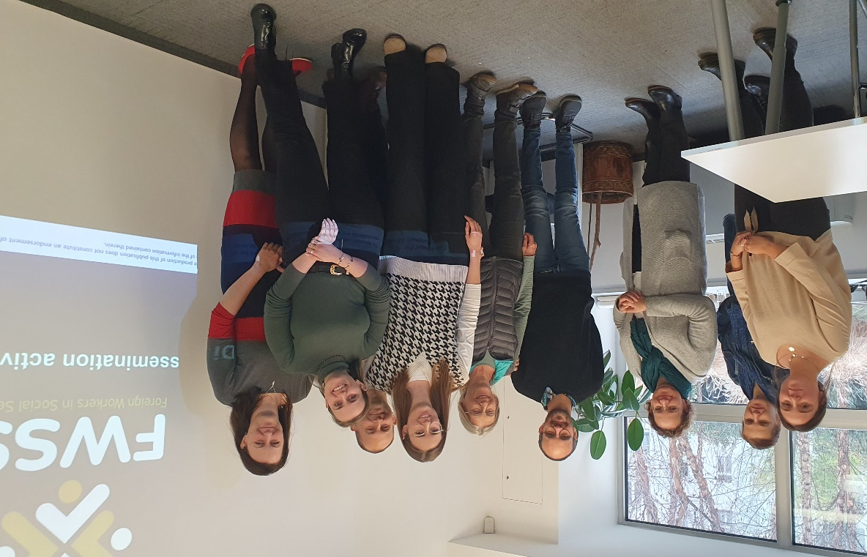

Contact person: Tereza Havelková; e-mail: project@apsscr.cz

