Draft Minutes
Transnational Partners Meeting - Brussels, Belgium
14.06.2023

Agenda
Agenda item
09:45 Opening remarks
- Sylvain Renouvel, Social Employers
09:55 Guidelines & Recommendations EU level
- Presentation of the guidelines at EU level – Alina Pavicevac
- Discussion and feedback from the workshops at national level – Moderator: Sylvain Renouvel
11:15 Recommendations and feedback focus group – Belgium
- Presentation of recommendations and feedback from the workshop – Tamara Gomez-Sanchez
11:35 Recommendations and feedback focus group – Austria (Service Mensch)
- Presentation of recommendations and feedback from the workshop - Service Mensch (20min)
11:55 Recommendations and feedback focus group – Czech Republic (CRA UZS) (20min)
- Presentation of recommendations and feedback from the workshop - CRA UZS
12:15 Recommendations and feedback focus group – France (Elisfa)
- Presentation of recommendations and feedback from the workshop – Elisfa (20min).
12:35 Recommendations and feedback focus group – Greece (AKMI)
- Presentation of recommendations and feedback from the workshop – AKMI (20min).
13:30 Conclusions and next steps - CRA UZS
- Summary of key remarks
- Next meeting
- Any other business

Participants
Sylvain Renouvel – Social Employers | Theo Bezerra - Elisfa
Alina Pavicevac – Social Employers | Vit Jásek - CRA UZS
Tamara Gomez-Sanchez – Social Employers | Jaromíra Kotíková - CRA UZS
Barbara Gscheitmayr - Service Mensch GmbH | Tereza Havelková - APSS ČR
Barbara Gurtner - Service Mensch GmbH | Věra Husáková - APSS ČR
Joëlle Garello - Elisfa | Konstantina Tsakalou - AKMI

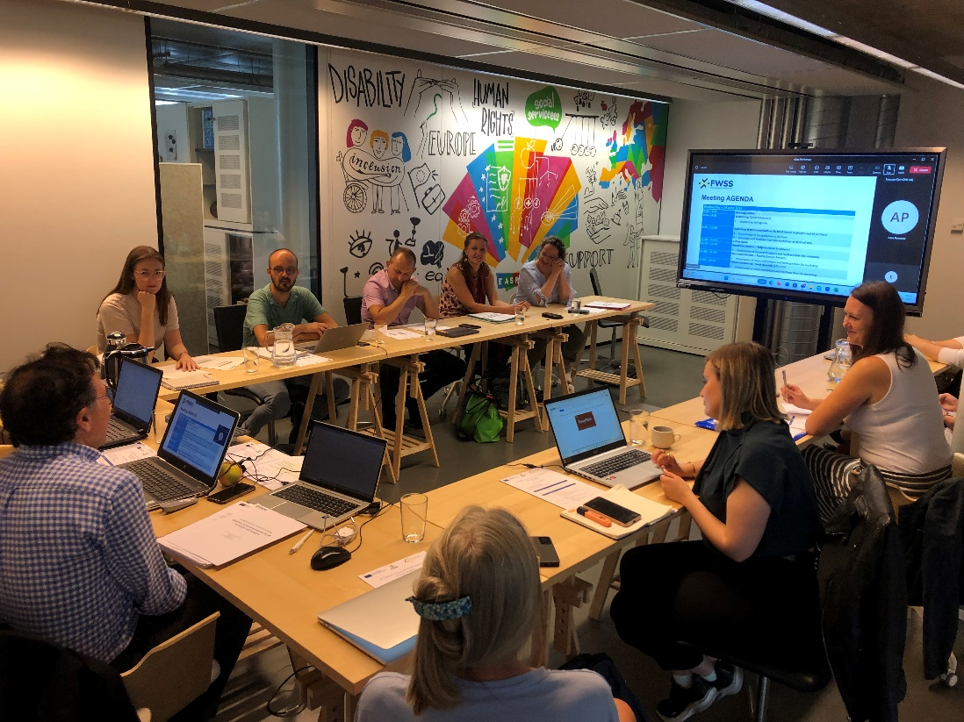
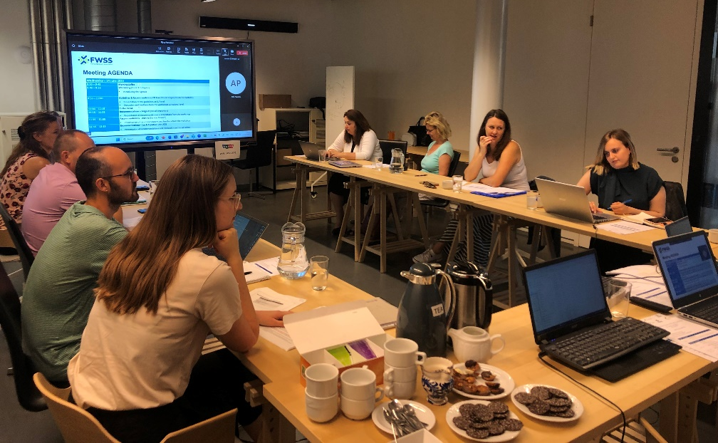
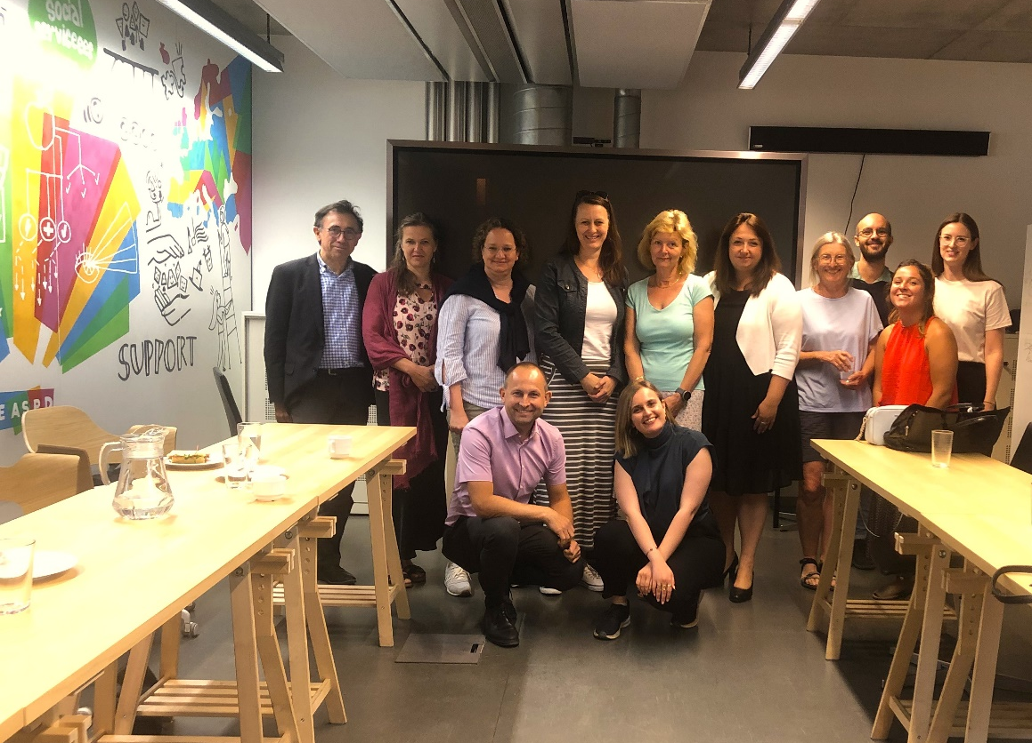

Minutes
Opening remarks
- Sylvain Renouvel opened the meeting
Guidelines & Recommendations EU level
- Alina Pavicevac presented the Guidelines & recommendations at EU level
- The target: HR personnel and managers
- The Guidelines focus on initiatives to address the four main challenges identified:
- Attractiveness of the sector
- Administrative procedures
- Support foreign workers at work
- Diversity and inclusion at the workplace
- Highlight the new EU Commission initiatives to work on skills.
- Partners are asked to add 3 good practices to the guidelines for each country.

Discussion and feedback from the workshops at national level
- Partners provided the feedback from the workshops, suggesting focussing on some aspects.
- Attractiveness of the sector
- focus on initiatives to make the sector more attractive by providing benefits that can be interesting for foreign workers (language courses, trainings, etc.)
- better accessibility to jobs in the sector by promoting the open positions through different ways (paper, online, migration offices, translating the offer, possibility to send CV in paper or bring it, etc.)
- Admin procedures
- Train a person of the organisation or the HR on the procedures. Have a person in the organisation with the knowledge/specialised on it but not only on this.
- Look for an intermediary organisation for support/training/provide info.
- In Greece, some organisations use mediators for the translations in the admin. Process but not with the paperwork.
- Create a manual with clear procedures for the organisation that can be updated and train HR and share the knowledge, provide the training to another organisation.

- Support foreign workers at work
- Look at the EU tool to skill foreign workers for the recognition of qualifications.
- Promote internal support but pay attention to not create difference between workers, a management plan needs to be created.
- Occupational profiles as a tool for the training.
- Diversity and inclusion
- Add some concrete examples on activities/initiatives to promote diversity and how to implement.
- In Greece diversity is seen as something to be don at an individual level.
Recommendations and feedback focus group – Belgium
- Tamara Gomez-Sanchez presented the recommendations for Belgium and the feedback from the workshop.
- 5 people participated in the focus group.
- 5 main recommendations. Participants agreed with the conclusions proposed.

Recommendations and feedback focus group – Austria
- Service Mensch presented the recommendations for Belgium and the feedback from the workshop.
- 1 Online Meeting with one participant
- 2 persons provided feedback per phone
- 5 persons provided feedback per E-Mai
- Overall, the guidelines were perceived as useful.
- Points discussed during the workshop:
  - Projects at regional level to employ foreign workers but nothing at national level.
  - Intermediate associations taking care of the admin. Procedures are too expensive.
  - Engage in projects, look for financial support available to work on diversity.
  - Work on welcoming initiatives, for example cultural exchanges.
Recommendations and feedback focus group – Czech Republic
- APSS presented the recommendations for Czech Republic and the feedback from the workshop.
- Points discussed during the workshop:
- Important to work on diversity, initiatives/trainings to build trust, look at initiatives to work on prejudice.
  - Importance of the soft skills (culture, communication verbal and non-verbal).
  - More cultural activities to address prejudices, stereotypes related to different countries, religions and cultures.
  - Put in place measures to tackle future challenges, related to integration and thus avoid xenophobia, etc.
Recommendations and feedback focus group – France
- Elisfa presented the recommendations for France and the feedback from the workshop.
- 7 people participated to the focus group.
- Points discussed during the workshop:
  - Recommendations to be adapted to all workers, not focus on foreign workers.
  - Flexible hours not only for foreign workers but also other workers that has this need.
  - Concrete examples of adaptations, maybe not only with language but other examples.
  - Be careful to create issues between colleagues.
  - Structured document with all the information about integration for employers and employees.
  - Vae = way to get a diploma showing you have the skills to implement the tasks
Recommendations and feedback focus group – Greece
- AKMI presented the recommendations for Greece and the feedback from the workshop.
- 10 people participated to the focus group.
- Points discussed during the workshop:
  - Promotion of social services among authorities and employment organisations: some of them are already cooperating, it is difficult to have a long-term cooperation.
  - Develop new ways of promoting the sector and jobs in the sector: social media already used but not accessible for some foreign workers, alternative: employment agencies, migration offices/organisations, leaflets.
  - There are trainings available in Greece to train on how to employ foreign workers.
  - The recognition of certificates is difficult. The certification process depends on the organisation policy.
  - Social dialogue seen as an opportunity.
  - Online platform provided to foreign workers to better understand the field, language, etc. related to their occupations.
  - Share good practices from organisations that implement cultural activities, etc (inclusive)
Conclusions and next steps - CRA UZS
- Next coordination meeting will take place in Greece.
- Any other business:
- The translation and design of the guidelines will be done by APSS and sent to partners for revision.
- The trainings on the curriculum (train the trainers) will take place in August-November
- The training curriculum will be developed by November. AKMI will write to partners, so they provide content for each unit.
- The in-person training in FR, BE and AT will be replaced by the MOOC. CRA UZS will draft a proposal of change to be sent to the national agency for approval.
- The MOOC will be created in December (modules and online training developed by AKMI)

